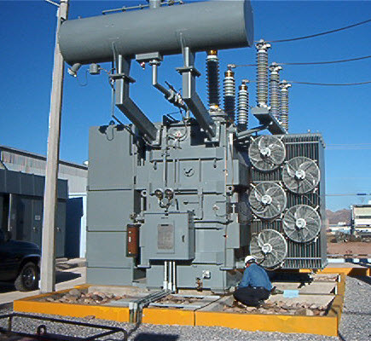

|  |  |
| --- | --- |
| System | **TX 01 Main Power Transformer** |
| Aim | **Electrical-Online Aim** |
| Site or Area | **Substation 101** |
| Location | **Bay 201** |
| Equipment Condition | **Online** |
| Instructions | The tasks listed in this document are to be carried out while the equipment is online.  WARNING: Never touch moving or energized equipment. |
| Special Notes |  |
| Hazards | Chemical Substances  Operating Machinery, Moving Parts, Pinch Points, Electrocution, Tripping & Slipping Hazards, Ergonomic Issues |
| Permits and Isolations | Job Hazard Assessment or Safety Risk Assessment  Always make sure your supervisor knows where you are working or what equipment you are servicing |
| Personal Protective Equipment (PPE) | Standard Site PPE |
| Other Safety Equipment |  |
| Tools |  |
| Materials |  |
| Resources | 2 Electrical |
| References | [Example Equipment Manual.txt](G:\\Programming\\EngineersTools\\WinWriter\\Equipment Manuals\\Example Equipment Manual.txt) |
| Prepared By | Your Name Goes Here |

|  |  |
| --- | --- |
| JSA - Job Safety Assessment | |
| TASK | DESCRIPTION |
| 1 | Analyse all conditions on site. Pay particular attention to changes since the previous day or shift. |
| 2 | Write down all risks |
| 3 | Determine and implement appropriate controls |
| 4 | Explain to all team members and sign. |

|  |  |  |  |
| --- | --- | --- | --- |
|  | Name | Date | Signature |
| 1 |  |  |  |
| 2 |  |  |  |
| 3 |  |  |  |
| 4 |  |  |  |
| 5 |  |  |  |

|  |  |
| --- | --- |
| SIL - Silica Gel Inspection | |
|  | |
| TASK | DESCRIPTION |
| 1 | Inspect colour of silica gel. Compare discolouration with chart. |

|  |  |
| --- | --- |
| WIR - Wiring Inspection | |
| TASK | DESCRIPTION |
| 1 | Visually inspect cabinet seals, glands, hinges, locks, switches, buttons and lamps condition. Test lamps |

|  |  |
| --- | --- |
| WIR - Wiring Inspection | |
|  | |
| TASK | DESCRIPTION |
| 1 | Visually and physically inspect wiring and connections condition. Check terminals and cores for loose connections. |

|  |  |
| --- | --- |
| FUN - Functional Tests | |
|  | |
| TASK | DESCRIPTION |
| 1 | Manually activate the micro switch on the Pressure Relief Valve |

|  |  |
| --- | --- |
| NOISE - Noise Inspections | |
| TASK | DESCRIPTION |
| 1 | Listen to transformer for excessive/abnormal humming. |

|  |  |
| --- | --- |
| EARTH - Earthing System Inspections | |
| TASK | DESCRIPTION |
| 1 | Visually inspect earth conductor, all earth connections inclusive of compound earthing connections and joins condition. |

|  |  |
| --- | --- |
| COOL - Cooling System Inspections | |
|  | |
| TASK | DESCRIPTION |
| 1 | Visually check cooling fins general condition and for oil leaks. |

|  |  |
| --- | --- |
| GEN - General Inspections | |
| TASK | DESCRIPTION |
| 1 | Check general condition of the transformer compound, including fence. |

|  |  |
| --- | --- |
| IDS - Labelling and Identifications | |
| TASK | DESCRIPTION |
| 1 | Visually check the identification (tag) label and the nameplate condition. |

|  |  |
| --- | --- |
| TEMP - Temperature Checks | |
|  | |
| TASK | DESCRIPTION |
| 1 | Check Oil Temperature, Winding Temperature and Oil Level. |

|  |  |  |
| --- | --- | --- |
|  | Reading | Notes |
| OTI |  |  |
| WTI |  |  |
| OL |  |  |